## Task report for [Issue 33](http://code.google.com/p/apollovms/issues/detail?id=33&can=1&colspec=Type%20ID%20Summary%20Owner%20Cc%20Status)

Prepared by Architecture Team: Abdullah, Tigran, Waseem

Objective:  
Submit one report in which you define:

* What are the contents of each of those models and which items are

worthwhile for us

* Conclude What are the steps to create each of them
* Suggest a good template for the design document we have to deliver on 16 March

Before we start with the explanation of design and analysis models, let’s have look on the relation between different documentations in the RUP.

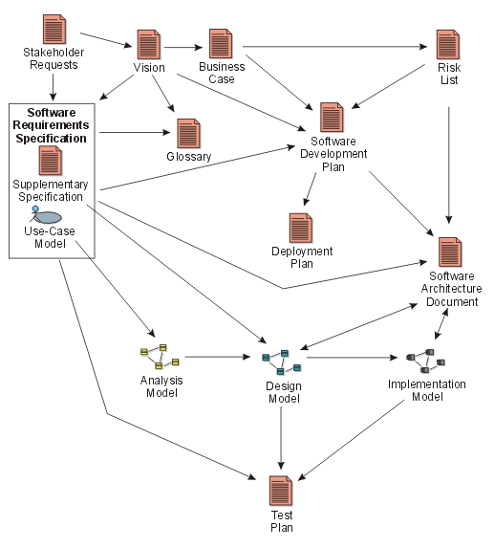

Figure . From <http://www.ts.mah.se/RUP/RationalUnifiedProcess/process/artifact/ovu_arts.htm>

#### Analysis and Design Model

The input artifacts for both models are:

* Use-case diagram
* Use-cases (testual representaion that we have in SRS)
* Supplementory spec. (non-functional requirements)

Analysis model is described as *“realization of use cases”* in [rup documentation](http://www.ts.mah.se/RUP/RationalUnifiedProcess/process/artifact/ar_amdl.htm).

And *use case realization* is explained in IBM’s web site with some steps.

1. **Supplement the Use-Case descriptions** (if necessary)

This step is for detailing the use-cases, in case if it is not enough detailed. Maybe we will need to detail some use-cases. For example I Manager Login we can add, system checks the profile in the database or something like that.

1. **Find Analysis Classes from Use-Case Behavior**

There are is a method that will used to find the analysis classes. At first we need to write down all the nouns of the use-case explanation we will call them candidate classes (we can escape the system). Using some questions we can find the actual analysis classes. Suggested questions can be found in the link above.

1. **Describe the responsibilities of the analysis classes**.

Create a table and with the tree columns: Class name, description and responsibility

1. **Create analysis class diagram**

The UML diagram should contain the classes and connections between the classes. Associations, relations, ertc.

1. **Analysis sequence diagram**.

It should show the interaction between the analysis classes. This step actually needed to make sure that the analysis classes are correct and their responsibilities are correct and the analysis classes can perform the use-case. If the use-case is not so complex we can skip this step.

1. **Define the attributes of the analysis classes**

The attributes of the analysis classes will be extracted from the responsibilities of the classes. Additionally the attributes can be added according to the domain knowledge

The outputs of these activities are use-case realization (UML diagram) and can be considered as the analysis model

Design model is the enriched version of analysis model. The steps below are for creating the use-cases design model.

1. Prepare design level sequence diagram.
2. Enrich the analysis classes with the operations (methods). The operations will be extracted from the previous artifact.
3. Simplify the analysis classes by grouping them into the groups of the classes (subsystems)
4. Describe persistence-related behavior. This step should describe how the objects will be persisted. This step will need to create design level sequence diagram with persistence layer. It will show the connection with the database subsystem and how the objects will be persisted from the database.

About the templates for architectural documentations

The course requires two different deliverables:

* Software Architecture Document ( Including the description of the most important design decisions)
* Detailed specification and design

RUP provides a template for the architecture document. It can be found [here](http://www.ts.mah.se/RUP/RationalUnifiedProcess/webtmpl/templates/a_and_d/rup_sad.htm)

Unfortunatelly, as can be seen in the image at the beginning of this document, RUP doesn’t contain a deliverable document about software design

We can use templates from some other organizations such as IEEE, but that should be discussed in detail.

As a conclusion, the content and steps for different models were given above. We have rup template for architecture but we don’t have any template for design. Both templates should be discussed in detail.

References.

<http://www.ibm.com/developerworks/rational/library/5383.html>

<http://www.ibm.com/developerworks/rational/library/content/RationalEdge/aug04/5670.html>